Requirement Specification
For 8 EA Nitrogen Booster and 8 EA Buffercylinder

- Requirements
1.1. Description of the requirement
The Danish Defense has acquired a new type of helicopter (Seahawk MH60-R), which shall operate from THETIS-Class, IVER HUITFELDT-Class and ABSALON-Class (ESBEN SNARE L17 has already a N2 booster solution onboard) - total of 8 vessels - in national/international missions. The helicopter hangar facilities onboard the vessels include compressed nitrogen (N2) which shall be available to service different mechanical components on the helicopters (tires, wings, accumulators, etc.). The existing nitrogen system onboard the vessels can only deliver up to 200 bar N2 and the new helicopter type requires up to 330 bar N2.

Most parts of the existing nitrogen system onboard the vessels are reused and modified (output panels, piping, etc.), but nitrogen boosters (N2-Booster) to boost nitrogen from standard 200 bar 50 L cylinders to >330 bar in a buffercylinder are required. The buffercylinders are also part of the supply.

Scope of supply:
8 pcs N2-Booster
8 pcs Buffercylinder

The vessels are supplied with standard 200 bar 50 L nitrogen cylinders. In suitable facilities are the cylinders connected to the nitrogen system. The nitrogen from these cylinders shall by an electrical driven compressor be boosted to a buffercylinder. The buffercylinder is connected to N2 system, which runs to the helicopter hangar where a N2 output panel is placed.

See drawing “Nitrogen System PI&D” (698.10.566.000.507). “N2-Booster” and “Buffer” (cylinder) marked with red on PI&D.

The N2-Booster and buffercylinder will be placed in closed rooms with direct access to open deck. The rooms are mostly dry, but equipped with only naturally ventilation so a marine environment is to be expected. The temperature in the rooms will follow the outdoor surroundings.
The room which shall contain the N2-booster is small and contains other mechanical equipment. The N2-Booster will be bolted to a foundation, which will make it easy for technicians to dismount the N2-booster to gain access to other equipment.

Helicopter technicians use nitrogen to service to the helicopter on a weekly basis, mostly low pressure (0-20 bar). On a monthly basis high pressure nitrogen is used (0-330 bar). DALO has no recordings which can be used to estimate an average volume used of N2.

The technicians connect hoses/tools to the N2 panel in the hangar and through the panel use/drain N2 from the buffercylinder to pressurize components on the helicopter or mobile cylinder.

When the pressure on the buffercylinder has dropped to under the required pressure, will the technicians manually start the N2-booster and fill the buffercylinder. The N2-Booster shall automatically stop when the pressure has reached max pressure (330 bar).

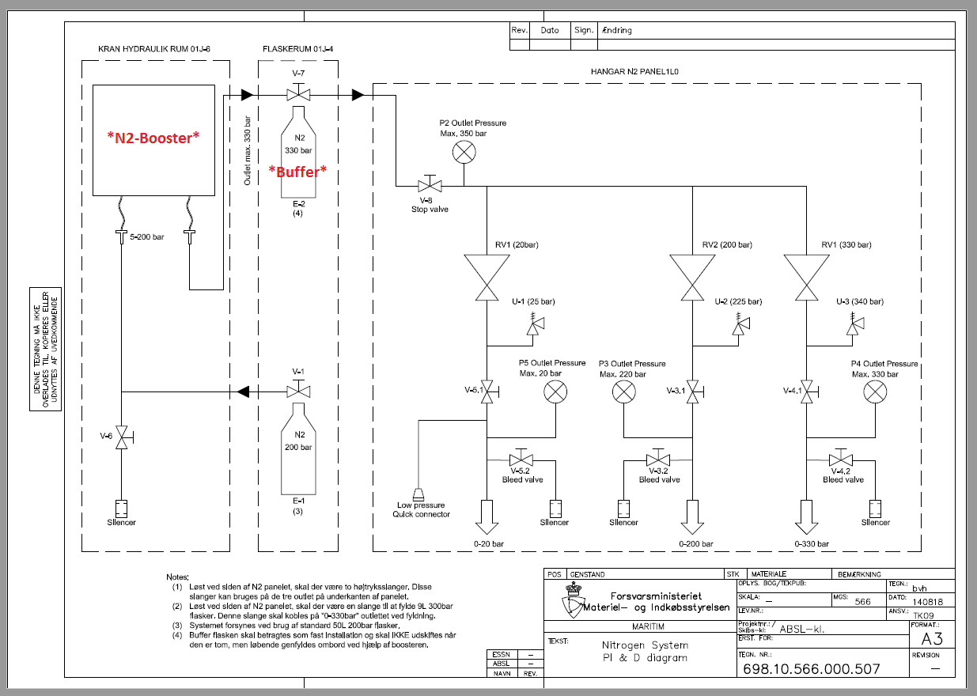
Nitrogen System PI&D
1.2. Description and definitions
The requirement specification, cf. section 1.4, describes all the requirements for the acquisition and consists of six columns with the following information:

"#" | ID number
"Requirement" | Requirement description
"Classification" | The classification of the requirement as further described in section 1.3
"DALO remarks" | Further information regarding the requirement
"Requirement compliance" | The tenderer's indication of compliance (YES or NO)
"Tender description" | Requirements regarding the tenderer's compliance description

1.3. Classification
All requirements are mandatory requirements (SHALL) and shall be fulfilled by the tenderer. If just one of the mandatory requirements is not fulfilled, the tenderer's tender will not be taken into further consideration.

1.4. Requirement and response sheet
# | Requirement | Classification | DALO remarks | To be filled out be the tenderer
 |  |  |  | Requirement compliance  (tick a box) |  | Tenderer's description
 |  |  |  | YES | NO
 | N2-Booster
1 | Electrical Motor  The N2-Booster shall be driven by an electrical motor. | SHALL
2 | Electrical Power Supply  The electrical motor shall be supplied with: 440V, 60Hz, 3 Phase without neutral, Isolated network. | SHALL
3 | Electrical System  Water ingress protection, shall be minimum IP33 or equivalent. | SHALL
4 | Compressor (1/8)  The N2-Booster shall compress nitrogen. | SHALL
5 | Compressor (2/8)  Working inlet pressure 5-200 bar, as minimum. | SHALL
6 | Compressor (3/8)  Shall be equipped with a inlet low sensor which automatically stops the compressor when inlet pressure is below 5 bar. | SHALL
7 | Compressor (4/8)  Shall be equipped with a vacuum sensor which automatically stops the compressor in case of vacuum in the system. | SHALL
8 | Compressor (5/8)  Outlet pressure up to 350 bar. | SHALL
9 | Compressor (6/8)  Shall be equipped with safety valves on outlet sides. | SHALL
10 | Compressor (7/8)  Outlet pressure shall be adjustable between 300-350 bar, as minimum. | SHALL
11 | Compressor (8/8)  Minimum F.A.D.:  110 L/min | SHALL
12 | Working conditions (1/2)  The N2-Booster shall operate in minimum following temperature range: +5 to +40 Celsius. | SHALL
13 | Working conditions (2/2)  All parts of product shall be surface treated to withstand a marine environment. | SHALL
14 | Steel frame (1/2)  The N2-Booster shall be mounted in a steel frame / crash frame to protect the N2-Nooster. | SHALL
15 | Steel frame (2/2)  The steel frame shall be equipped with lashing eyes (4 pcs), one in each corner on top of the frame, for lifting/craning. | SHALL
16 | Dimensions  Overall dimensions of N2-Booster with steel frame shall maximum be:  Length: 850 mm  Width: 450 mm  Height: 650 mm | SHALL | Please inform dimensions of your product.
17 | Control (1/3)  Control panel shall be equipped with START/STOP and pressure gauges to see inlet and outlet pressure. | SHALL
18 | Control (2/3)  The N2-Booster shall be manually started and stop automatically when required maximum pressure (330 bar) is reached. | SHALL
19 | Control (3/3)  It shall be possible to decant nitrogen through the compressor to the buffer cylinder. | SHALL
20 | Commissioning  The N2-booster shall be delivered fully commissioned (pressure setting adjusted to 330 bar, oil on compressor) so the N2-booster is ready to work after installation. | SHALL
21 | Documentation  Supplier shall provide a USER MANUAL, with at least the following subjects: System description, “how-to-use” guide, maintenance procedures. | SHALL

 | Buffercylinder
22 | It shall be possible to charge the cylinder with up to 350 bar nitrogen. | SHALL
23 | Cylinder shall be of the following type:  HP Cylinder 50 L 350 Bar. Nitrogen Culinder Acc. To ISO 9809-2 norm and directive TPED (”PI” marked). Thread in cylinder neck: 25E – With neck ring W80.  Or equivalent. | SHALL

 | Other Requirements
24 | The product shall comply with Danish Working Environment Authority applicable rules:  ”Maskiner og Maskinanlæg  At. Vejledning  Tekniske Hjælpemidler – B.1.3”  Or equivalent. | SHALL
25 | Time of delivery:  15.03.2019 | SHALL

