Requirements for an EA-tool

Background
The Danish Ministry of Immigration and Integration wants to improve the daily work with creating, maintaining and retrieving it-relevant documentation and artefacts.

Our focus for the moment is on the following artefacts:

- Process landscapes, processes and workflows in BPMN
- Master data on applications (for instance owner, description, ISO27001-classification, numbers of users, type, contact persons and so forth) in tabular form
- Concept and data models in UML
- A variety of context diagrams in Archimate
- System documentation and guides for installation and operations in Word or PDF
- Documentation on integrations in Word or PDF

We are not focusing on technology/infrastructure-artefacts because our it-operations is outsourced – and the suppliers are responsible for this kind of documentation.

We do expect though to import data from supplier systems (for instance application master data) and make links to data and documents in the supplier systems.

Furthermore we have recently acquired an information security management tool (ISMS) for risk assessments, compliance processes and controls for ISO27001 and GDPR (Neuparts Secure ISMS).

The EA-tool is therefore not supposed to contain these kinds of documentation.

In other words we have a multi-tool strategy, where we keep specific documentation in different tools, which our colleagues use in their daily work to create, maintain and retrieve different artefacts and views.

We have no intentions of gathering all information in one tool.

The EA tool should primarily be used for modelling in BPMN, UML and Archimate, but it could also be used for establishing a planned overview/catalogue (see figures on the following page).
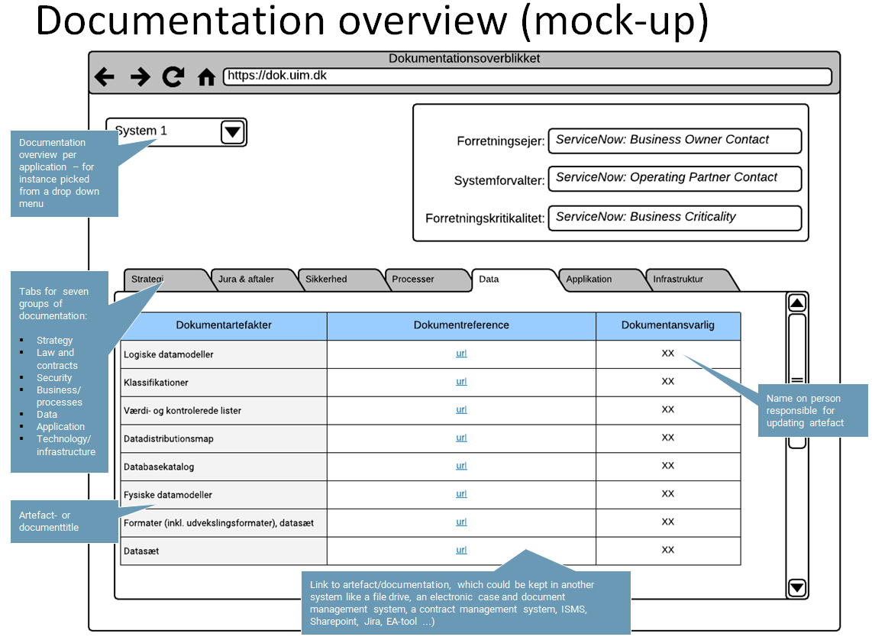

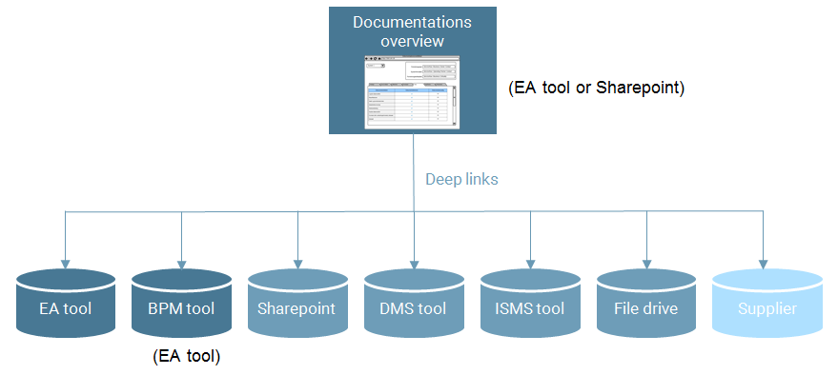

Generel requirements

What? | How | Possible?
- Operations | The EA-tool must be operated on premise at Statens It
- Archimate | The EA-tool must support modelling in Archimate
- UML | The EA-tool must support UML according to the way the standards are used in the Danish government – as decided by the Agency for Digitisation in the Ministry of Finance.
- Help text, guidelines, descriptions and documents | It should be possible to add help text, guidelines, descriptions and/or documents via mouseover, links or text elements to the elements and connections in the different views in Archimate, UML and BPMN
- Linking objects and diagrams | It should be possible to create links between different diagrams/views and across Archimate, UML and BPMN
- Import of standard formats | It should be possible to import Visio, Archimate and UML formats
- Import of data | It should be possible to import data from ServiceNow and Excel spreadsheets
- Export to PDF | It should be possible to export all kinds of views to PDF
- Export to Excel | It should be possible to export lists to Excel
- Multiple versions of the overall enterprise architecture | The EA-tool must support multiple versions/plateaus/projects of the architecture – in order to identify dependencies between projects affecting the architecture.  We have continuously several projects going on at the same time, and they will each of them in time change the architecture. Therefore we want to be able to mo-del the changes in the as-is architecture as a result of project A – and then model not only the changes intended by project B on the as-is architecture but also on the planned architecture resulting from the changes planned in project A.
- Deep links | It should be possible to make deep links to all views
- Documentation overview | The EA-tool should support the configuration of an application catalogue/table as illustrated on the previous page.
- User administration - control | It should be possible to get an overview or matrix of users and their rights
- User administration - AD-integration | It should be possible to integrate the user registry with AD
- Single sign on | It should be possible to integrate with Windows authentication

Specific requirements regarding business process documentation

What? | How? | Possible?
- BPMN | The tool must support BPMN – preferably including warnings and help text if a diagram differs from the standard notification.
- Search engine | Users should be able to find relevant processes for instance through search on their role (Owner/Manager/ Designer/Performer), process title - or full text search within the actual activities.  A user with a role (Owner/Manager/Designer/ Performer) must be able to find all the processes related to him or her.
- Usability | Users must be able to create and update process diagrams easily.  Usability in designing processes must be at least as easy as in Microsoft Visio 2016 – including functions like smart drawing, adjustment and automatic adjustment of diagram elements
- Process landscape | It must be possible to create a hierarchy of processes, from a high level view of the landscape based on for instance a business model canvas or capability model – over processes and subprocesses – to workflows on the lowest level.
- Navigation | It must be possible to click your way through the process landscape and between related processes
- Version control | It should be possible to either overwrite actual versions or create a new version of a process. And it should be possible to access old versions based on time stamps.
- Linking | It must be possible to make deep url links to diagrams on all levels of the process landscape
- Print and export to PDF | It should be possible easily to make nice PDF’s and prints of the diagrams - showing only the diagram and title of diagram.  It should also be possible to make PDF’s/prints of diagrams including relevant descriptions and guidelines
- User administration - rights | It should be possible to separate user rights into groups:  - Read only (process performers)  - Update (process designer and manager)  - Create and delete (process designer and architect)  - Administer (system administrator)
- Metadata about processes | It should be possible to get an overview over the users who have roles (Owner/Manager/Designer) related to a specific process.
- Notification when processes are changed | It should to possible to configure automatic notification of different roles/users related to a specific process, when the process is changed.

Pricing

The Ministry of Immigration and Integration asks for a specified offer including the total costs over a period of 4 years.

The total costs must include all expenses billed by the vendor – like for instance licenses for all relevant software components, maintenance, implementation, installation, configuration, support, training and e-learning.

Expected number of users:
- Read only: 100
- Create, delete, update: 5-10 (depending on license policy regarding floating licenses)
- Administrators: 2

